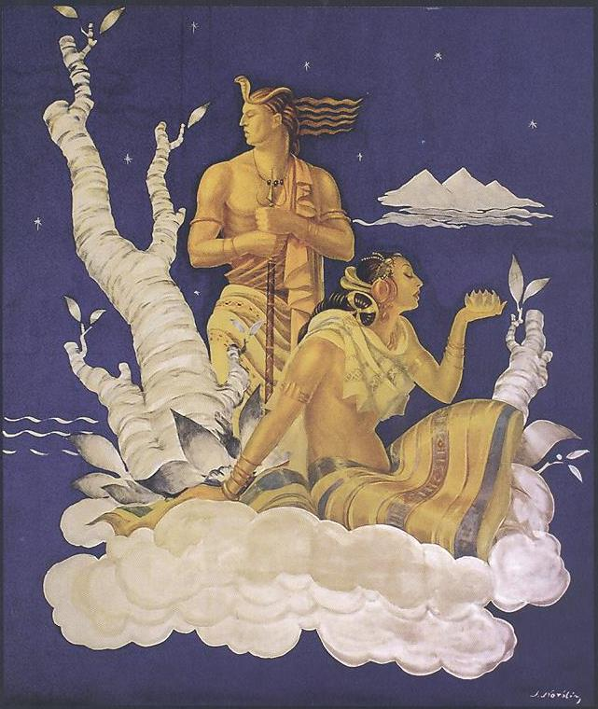  - THE INDO-AMERICAN HERITAGE MUSEUM &  - THE POLISH MUSEUM OF AMERICA  - INVITE YOU TO  DISCOVER A POLAND-INDIA CULTURAL HERITAGE LINK AT A SPECIAL SHOWING OF THE DOCUMENTARY FILM  CHITRAANJALI: STEFAN NORBLIN IN INDIA  COURTESY OF THE EMBASSY OF THE POLISH REPUBLIC IN NEW DELHI  AND THE POLISH NATIONAL AUDIOVISUAL INSTITUTE (NinA)  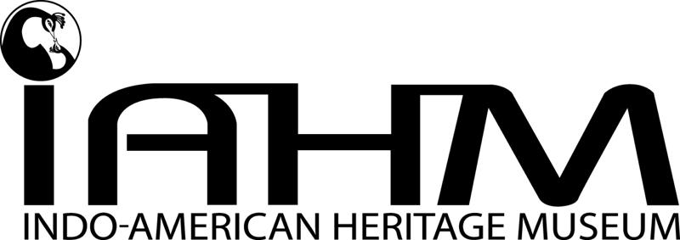 | ECO AND THE MAHARAJAS, ETHNIC FOOD, INDIAN DANCE, 1930’S POLISH TANGO 6:00 PM | ART DECO AND  MAHARAJAS  ETHNIC FOOD  INDIAN DANCE  1930’S POLISH TANGO  6 PM WEDNESDAY  NOVEMBER 13, 2013  THE POLISH MUSEUM OF AMERICA  984 N. MILWAUKEE AVENUE, CHICAGO, IL 60642  Donation: $25  Students with ID: $10  Cash Bar  renowned Polish artist Stefan Norblin BEGAN WORK in 1941 FOR THE princely houses OF Gujarat and PatnA. court painter to maharajah Umaid Singh of Jodhpur, hE CREATED intriguing and stunning ART DECO murals at Umaid Bhawan Palace, for which he also designed furniture and interiors. the largest single collection of this unique Polish art IS NOW IN INDIA. The film by Margaret Skilba, a Pole living in India, EXpLOREs PolISH RESTORATION EFFORTS AND Norblin’s life and work in Warsaw, Mumbai, Morvi, Jodhpur and the u.s.  Consulate of the Republic of India Consulate of the Republic of Poland  The Chicago Art Deco Society  FREE PARKING EASY ACCESS FROM HIGHWAYS AND PUBLIC TRANSPORTATION  www.iahmuseum.org www.polishmuseumofamerica.org  Questions? Call 773 384 3352  [Street Address]  [City, ST ZIP Code]  [Telephone]  [Web Address]  [Dates and Times]  [Dates and Times]

