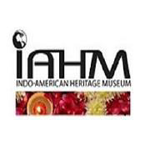
The Indo-American Heritage Museum
presents
Amazing India

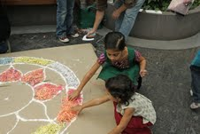
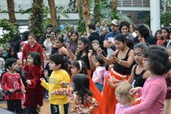
Sunday, March 17, 2013
Navy Pier’s Crystal Gardens
600 E. Grand Avenue
12:00 p.m. - 5:00 p.m.

Celebrate Indian food, artistry and dance as we participate in Navy Pier’s “Neighborhoods of the World” series.

Performances by:

Kalapriya Center for Indian Performing Arts
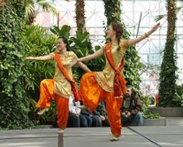
Natya Dance Theatre
Chitrahar Cultural Academy
Anila Sinha Foundation
Punjabi Association
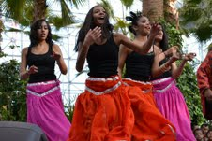
Satrangi Garba Group

Free Admission!

